(11) Post | LinkedIn
Top SQL Questions Every Java Developer Must Know in Interviews
As a Java Developer, SQL isn’t optional — it’s crucial. Interviewers often test not just your coding skills but also how well you understand databases.
Here are some must-know SQL questions 👇
🔹 What is the difference between INNER JOIN, LEFT JOIN, RIGHT JOIN, and FULL JOIN?
🔹 Explain Clustered vs Non-Clustered Indexes with examples.
🔹 How does Normalization work? Why is it needed?
🔹 Write a query to find the 2nd highest salary from an Employee table.
🔹 What are Transactions? Explain ACID properties.
🔹 Difference between WHERE and HAVING clause.
🔹 How to improve query performance using Indexes and Execution Plans?
🔹 What are Stored Procedures, Functions, and Triggers? When to use each?
💡 Pro Tip: Practice writing queries with real data — that’s what impresses interviewers the most!
📌 Save this post for your next interview prep.
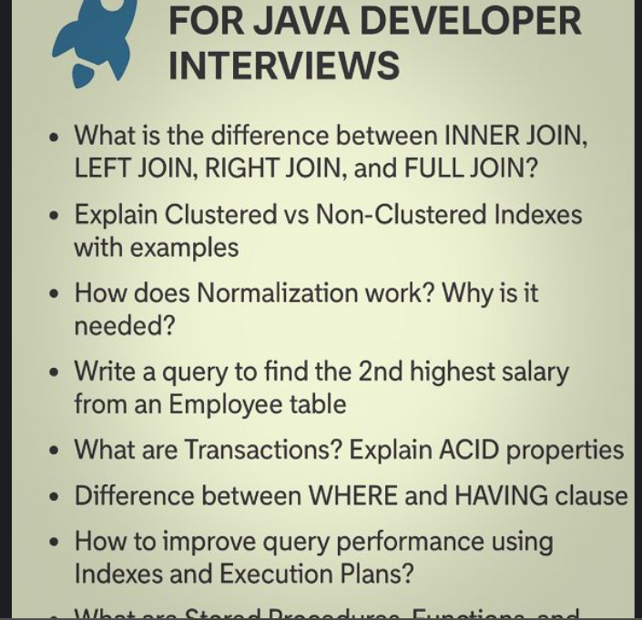

(11) Post | LinkedIn
🚨 Java / Backend Interviews me SQL ignore kiya?
Shortlist wahi ruk jaati hai.
Here are REAL SQL questions asked in Java & Backend interviews
(banking, product companies, service-based — sab jagah):
1. Difference between WHERE and HAVING — interviewers ask this to check GROUP BY clarity
2. INNER JOIN vs LEFT JOIN — when does LEFT JOIN return extra rows?
3. Can a table have multiple UNIQUE keys but only one PRIMARY KEY? Why?
4. What happens internally when you create an INDEX?
5. When should you NOT use an index even if queries are slow?
6. DELETE vs TRUNCATE vs DROP — which one is faster and why?
7. How does a composite index work? Order matter karta hai?
8. Difference between clustered and non-clustered index
9. What is a covering index? Real use case?
10. How does SQL handle NULL in comparisons?
11. What is ACID and which part is hardest to guarantee?
12. What is a transaction isolation level? Which one is default?
13. Dirty Read vs Phantom Read — real production example
14. Difference between UNION and UNION ALL (performance angle)
15. What is an execution plan and how do you read it?
16. Why GROUP BY fails without aggregate functions sometimes?
17. How to find duplicate records without using GROUP BY?
18. What is a self join and where is it actually used?
19. How does pagination work internally using LIMIT & OFFSET?
20. Why OFFSET pagination becomes slow for large tables?
21. What is a VIEW and when should you avoid it?
22. Stored Procedure vs Query from Java — which is better and why?
23. How to prevent SQL Injection at database + Java level?
24. What is normalization and when is denormalization better?
25. What happens when a transaction fails midway?
26. What is a deadlock? How do databases resolve it?
27. How does foreign key improve data integrity but reduce performance?
28. What is write amplification in databases?
29. Difference between OLTP and OLAP databases
30. One SQL optimization you did in real project?
💡 Interview Tip:
Most rejections are NOT because of Java code…
but because candidates can’t explain SQL decisions clearly.

(11) Post | LinkedIn
🔹 SQL
Query to find departments with more than 1 employee.
Difference between INNER JOIN, LEFT JOIN, and RIGHT JOIN.
How indexing improves performance?
Write query to fetch 2nd highest salary in each department.
Difference between Primary Key, Unique Key, and Foreign Key.
Explain ACID properties in DB transactions.
What is normalization & why is it needed?

